Analysis pipeline:
N = 14 trials from 5 mice.
First detrend the signal by fitting and subtracting a double exponential. (This fails in some cases and causes problems in others by trying to fit large puff responses. On the To Do list.)
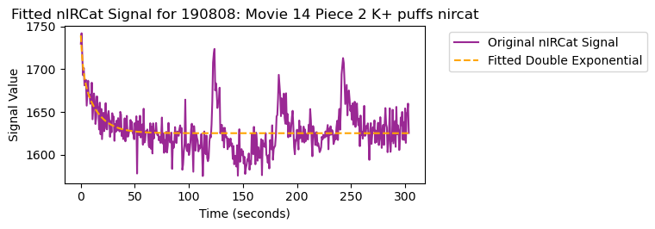
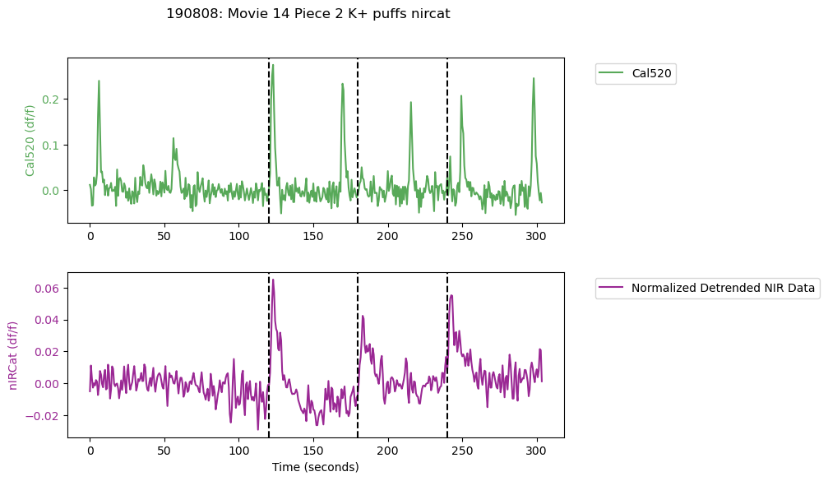
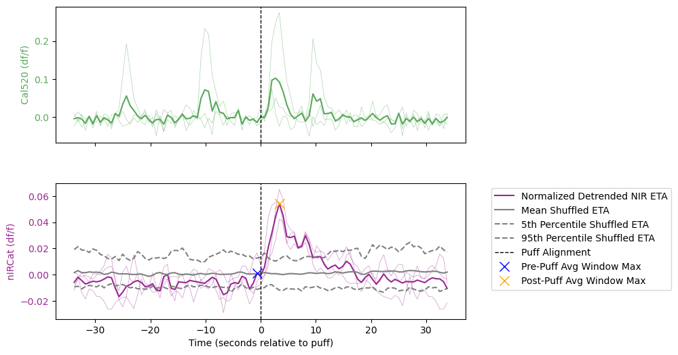
Then construct puff-triggered averages. To compare puff-triggered nIRCat signal to random fluctuations, shuffle the data (n=100 shuffles of k = (number of actual puffs) random trigger frames). Measure average of three frames around peak of nIRCat signal in the 10 second pre- and post-puff windows.

Negative controls: two trials from one mouse puffing ACSF on the sensor and one trial puffing K+ on SWCNT without the single stranded DNA that confers DA sensitivity.

K+ puffs onto bare SWCNT:
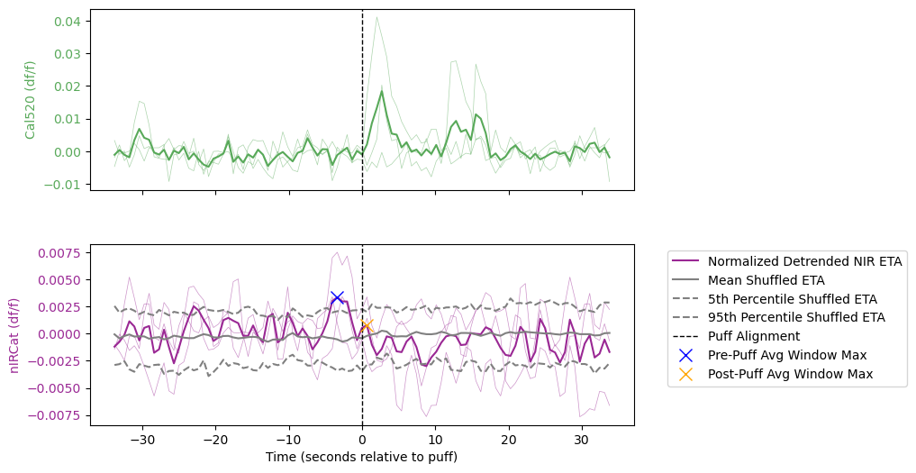

ACSF puffs onto functional sensor:
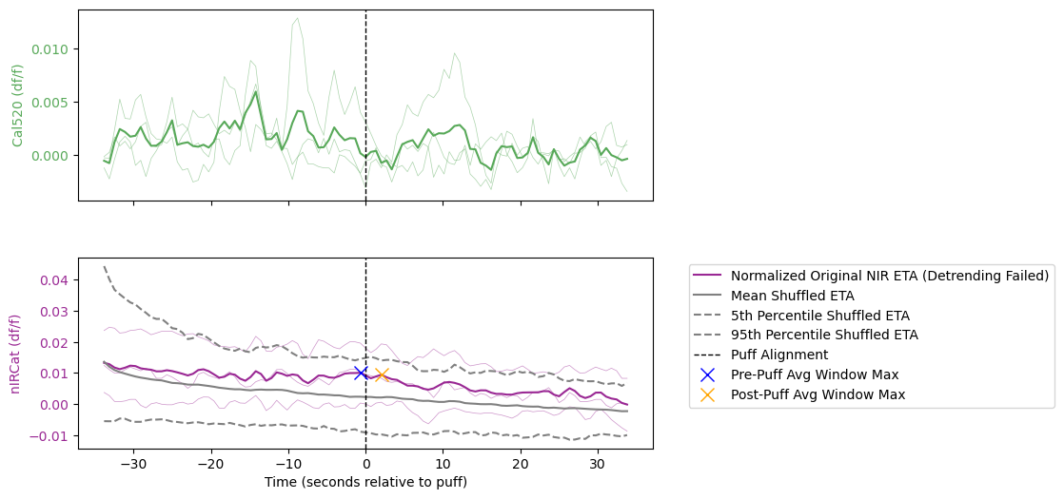

Large, integrating responses to 2.5 M K+ puffs:
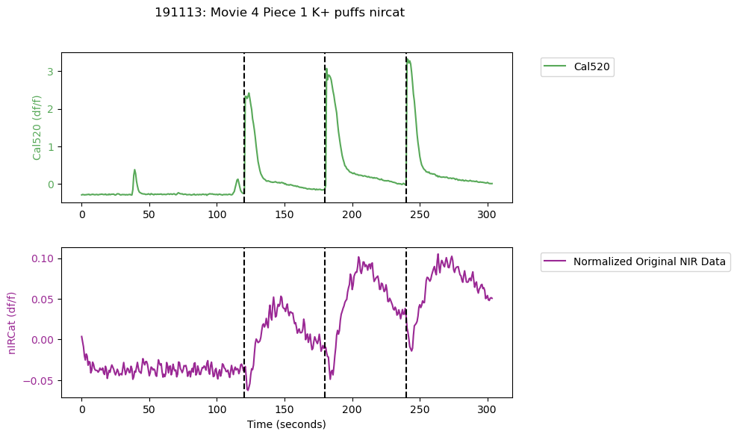

How to see the full dataset:
I will share the analysis code and data as a Github repository. Once you download the repository, open the python notebook, change the ‘basepath’ at the top of the notebook to the location of the repository on your computer, and run the notebook. Ensure you have all the modules installed in your python environment. This should reproduce all the analysis shown here and make plots of the traces for every trial.
You can also perform your own analyses on the csv data files in the ‘k_puffs’ subfolder and make sense of the data by inspecting the ‘dopamine imaging.csv’ file that provides metadata for each trial.

